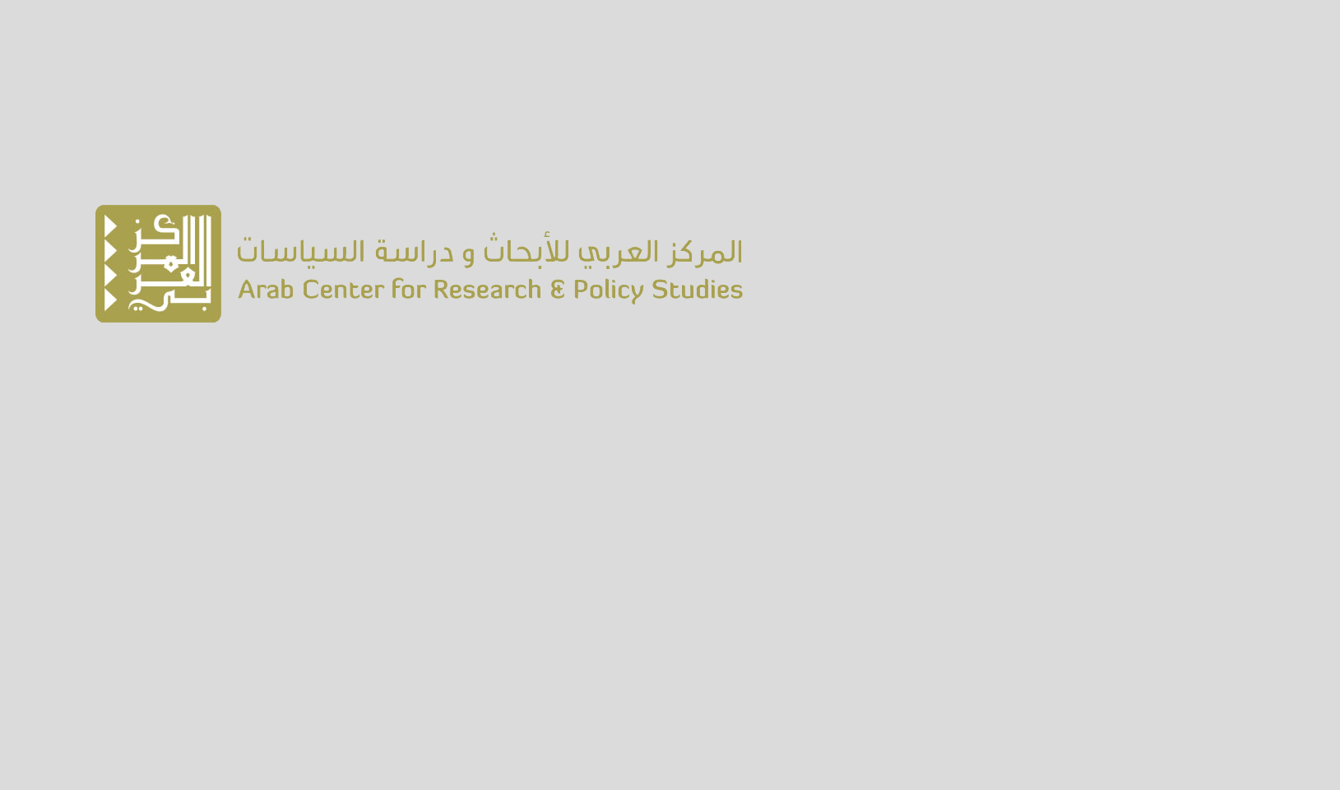

Assessment Report

**De Mistura’s Plan for Syria: Small Steps Running up Against Big Obstacles**

Policy Analysis Unit - ACRPS | Nov 2014

De Mistura’s Proposals for Syria: Small Steps Running Up Against Big Obstacles

Series: Assessment Report

Policy Analysis Unit – ACRPS | Nov 2014

Copyright © 2014 Arab Center for Research and Policy Studies. All Rights Reserved.

____________________________

The Arab Center for Research and Policy Studies is an independent research institute and think tank for the study of history and social sciences, with particular emphasis on the applied social sciences.

The Center’s paramount concern is the advancement of Arab societies and states, their cooperation with one another and issues concerning the Arab nation in general. To that end, it seeks to examine and diagnose the situation in the Arab world - states and communities- to analyze social, economic and cultural policies and to provide political analysis, from an Arab perspective.

The Center publishes in both Arabic and English in order to make its work accessible to both Arab and non-Arab researchers.

**Arab Center for Research and Policy Studies**

PO Box 10277

Street No. 826, Zone 66

Doha, Qatar

Tel.: +974 44199777 | Fax: +974 44831651

www.dohainstitute.org

Table of Contents

Introduction 1

A Plan to Break the Deadlock 1

De Mistura’s Wager 2

Obstacles to the Initiative 3

# Introduction

Special UN Envoy to Syria Staffan de Mistura is on a mission to mobilize international and regional support for his proposal to “freeze” conflict in various regions of Syria, starting with Aleppo. Mistura hopes to secure a series of truces and temporary reconciliation pacts that could enable the exercise of autonomous administration in these areas. These will be validated through the formation of local councils, whether elected or appointed through consensual agreement, thus enabling the representation of Syria’s armed opposition factions, according to their respective size and effectiveness. De Mistura, however, is likely to face serious obstacles in carrying out his plans.

# A Plan to Break the Deadlock

De Mistura was appointed as Special UN Envoy to Syria at the start of July 2014, when hopes for a political solution to the Syrian crisis had run aground with the failure of the Geneva 2 conference, and the subsequent impasse in launching a new round of negotiations between the Syrian regime and the opposition. The regime’s insistence on holding presidential elections in Syria on June 3 had dashed any lingering hopes Lakhdar Brahimi might have had in seeing the Geneva 1 outcome – which stipulated the establishment of a fully-fledged transitional governing authority paving the way for a comprehensive solution to the crisis – come to fruition. De Mistura’s appointment coincided with the rise of ISIL and its expansion across Syria and Iraq, following the fall of Mosul on June 10, and the subsequent declaration of the Islamic Caliphate on June 29. Developments on the ISIL front led to a decline in international interest in finding a political solution to the Syrian crisis, in addition to the high-priority focus, by the US in particular, on negotiations with Iran over its nuclear program and containment of ISIL.

De Mistura’s reading of the web shifting international and regional interests in Syria has come from ample experience as former UN Envoy to Afghanistan, and as an international mediator in conflict-ridden countries such as Kosovo, Lebanon, Iraq, and Sudan among others. De Mistura thus started from the notion that the complexity of the Syrian crisis, with its intricate civil conflict and even more complex international dimensions, makes a solution intractable in the short or medium term. His approach thus differs from that of his predecessors Kofi Annan and Lakhdar Brahimi, placing a premium upon partial solutions and modest objectives centered on reducing the level of violence and improving the delivery of humanitarian assistance – or in his words “sowing the seeds of a comprehensive political process”– rather than the continued expectation of an emerging international and regional consensus that would lead to the “Geneva 1” agreement being implemented. In other words, rather than coming up with a comprehensive vision to solve the Syrian crisis, de Mistura is moving the wheels forward towards creating the impression that his plan is feasible and that it has a good chance of success.

# De Mistura’s Wager

To carry out his plan, de Mistura has counted on the Syrian regime and Iran to approve his proposals, which in many ways can be said to correspond to their own. Temporary truces and reconciliation agreements in vital besieged areas of Syria have been well underway since the start of the year. Breakthroughs have been seen in a number of important military fronts: al-Mu’adamieh, Babila, the southern districts of Damascus, al-Wa’ir district of Homs, and, notably, the agreement for the evacuation of fighters from the old city of Homs. There are some critical differences, however, between the regime’s idea of truces, and those of de Mistura’s. While the regime made any distribution of humanitarian aid and treatment of its detainees contingent on an area’s decommissioning of its heavy weaponry, enabling it to later storm the area (as happened in the old city of Homs and as is currently taking place in the al-Wi’ir district), de Mistura’s proposed freeze allows each side to retain its military capability.

As a result, despite the note of welcome expressed by the Syrian regime’s president to the UN Secretary-General’s envoy’s statements, following their meeting in Damascus on September 12, Assad avoided taking a clear stand on the proposed initiative, saying simply that it was “worthy of study”. For his part, de Mistura in his statements chose to ignore the political solution that had been accepted by the opposition in “Geneva 2”. Syria’s opposition is itself split on de Mistura’s proposals, between complete rejection (on the part of some members of the National Coalition of Syrian Revolutionary and Opposition Forces, the interim government and factions of the armed opposition) and conditional acceptance, as expressed by the head of the Aleppo Military Council Brigadier Zuhair al-Saket[1]. [1]

The split in views goes beyond the country’s political and military opposition, and extends to anti-regime segments of the population. There are those who believe that the ideas presented offer at best truncated and piecemeal solutions and are therefore tantamount to a coup against the revolution and the surrender to the regime, with appalling disregard for the sacrifices made. Others perceive it as being simply a temporary freeze of the war that could relieve their plight and lessen their suffering.

The current division can be considered a continuation of an earlier debate around the feasibility of local truces and reconciliation initiatives, and around the initiatives launched by the former head of the opposition coalition, Moaz al-Khatib. With the prolongation of suffering and ever-shifting international priorities, de Mistura has carried on with rounding up support for his proposals. Under the heading “Stopping the Advance of ISIL”, de Mistura has counted upon tacit Western acceptance and the absence of any objection from international circles, or from the regional actors involved in the Syrian crisis. He is also counting on Russian support and an exertion of pressure on the regime to accept his proposals without modification, along lines seen during the previous chemical weapons disarmament. He then hopes the UN Security Council may adopt his initiative as binding for all parties, as a basis for a country-wide cease-fire or at the very least in some particularly volatile fronts. This would complement Security Council resolution 2139 calling for the delivery of humanitarian aid to besieged areas and inviting all parties to "put an immediate end to all acts of violence that lead to human suffering in Syria."

# Obstacles to the Initiative

While several internal and foreign parties have welcomed de Mistura’s proposals, the translation of these proposals into practical steps seems to clash with stances expressed (albeit indirectly) by the main parties involved in Syria’s conflict.

**The Regime and Iran**: De Mistura’s proposals are similar to the truces and reconciliation projects proposed by Iran. They differ however in important details and in their implementation mechanisms. Iran believes that the current military balance of power greatly favors the regime, particularly after the strikes of the international coalition against ISIL and the likes of Jabhat al-Nusra and Ahrar al-Sham, which have reinforced the regime’s military position, especially in Aleppo, as American officials have themselves admitted. Despite the vital importance of Aleppo, the regime lacks the troop numbers and advanced weaponry which could enable it to decide the battle. This could be the factor that will eventually push the regime to endorse the de Mistura proposal solely with regard to the city of Aleppo, while continuing to seek to take control of Aleppo’s northern rural countryside, and lift the continuing sieges on the towns of Nabul and al-Zahra. These towns could then form a base from which military campaigns towards the city and against ISIL in the city’s eastern countryside could be launched. The regime can then successfully present itself as an assisting party to the international coalition against ISIL. Yet, both the regime and Iran may be fearing any promotion of the de Mistura proposals internationally, lest they turn into a binding UN resolution. Hence the regime’s keenness - as ever in its dealings with political initiatives - to show itself as ‘flexible’ in studying the proposals, without making any commitment to their acceptance. The position of Ali Akbar Velayati, international affairs advisor to Iran’s Supreme Leader Ali Khamenei, can also be understood in this light: he rejected, on November 1, de Mistura’s proposal to establish what he had called "safe areas" in Syria.

**The Armed Opposition**: De Mistura has suggested truces and reconciliation efforts in areas controlled by the armed opposition, but without taking into consideration its various capabilities, military positions or stands regarding his proposals. For example, he calls upon the armed opposition to freeze its military position in the city of Aleppo, while at the same time calling upon them to rally to the call to combat ISIL and the jihadist movements. The Free Syrian Army, however, lacks sufficiently strong contingents in the city of Aleppo so that it can undertake such a course of action. Jabhat al-Nusra and the Ansar al-Din front are both classified by the West as terrorist movements (along with Ahrar al-Sham which is another target of the international coalition’s aerial campaign); these together form the largest contingents on the ground and are most powerful militarily in the city. How these factions could freeze their combat in Aleppo in order to devote themselves to attacking ISIL in concert with the international coalition remains an unanswered question. Recent developments in the whole northern area of Syria, with the growing influence of Jabhat al-Nusra and the Jund al-Aqsa faction and the decline of the Free Syrian Army, add to questions about the feasibility of the proposals that have been put forward.

**The Turkish Position**: The Turkish government has avoided officially commenting on de Mistura’s proposals, but differences in vision are evident. With the UN envoy seeking to freeze the fighting in Aleppo and promote an all-out campaign against ISIL, Turkey warns of the possibility of the fall of the city to the regime and of a consequent large flow of refugees. For Turkey, its participation in the international coalition against ISIL is also linked to its wish to overthrow the regime of Bashar al-Assad and to establish safe havens and no-fly zones. In addition, Turkey was upset with de Mistura’s call to open the Turkish border to volunteers of the Kurdistani Workers’ Party (PKK), classified by Turkey as a terrorist party, to fight against ISIL alongside units of the Kurdish People’s army in Kobane. Turkey dismissed de Mistura’s plea as "irresponsible". While touring most of the countries that are active and influential in the Syrian crisis, de Mistura has thus far neglected to visit Turkey. Given Turkey's importance and influential role in northern Syria, proposals to freeze the fighting in Aleppo without coordination with Turkey would seem, to say the least, unrealistic.

**The Russian Position**: With the breakdown of hopes for a political solution, the rise of ISIL, and the consequent rush of Western and regional military intervention, Russia seems less present in the Syrian crisis. While the air strikes of the international coalition against ISIL certainly worked to the advantage of Russia’s ally, Russia is wary of a possible change in plans and objectives stated in future stages of the coalition’s campaign. Its fears have been reinforced by continued US disregard of its requests for a UN Security Council decision regulating coalition operations in Syria and defining targets with precision. Russia believes that the entrance of the West into the Syrian crisis by means of the coalition and the fight against ISIL may serve to gradually marginalize its own central role in any future solution to the crisis. So, while welcoming de Mistura’s proposals, Russia sees a need for them to be implemented in a broader political framework, with a revival of the political process via negotiations, and a new round under the name "Moscow 1" or "Geneva 3" . Moscow also sees that the variables in the Syrian file, especially after the rise of ISIL, can provide the regime with opportunities to maximize its interests, and to promote its vision in any future negotiations. To activate this, Russia has hosted Syrian opposition members who would not mind returning to the negotiation process to resolve the crisis, and has also extended an invitation to a delegation from the regime, to persuade it to follow the same path. For this reason, it is unlikely that Russia would support de Mistura’s proposals: adoption of these proposals in a binding Security Council resolution that would probably contribute to the marginalization of Russia's role in the Syrian crisis.

De Mistura's proposals might have some chance of being implemented, but the obstacles that loom ahead are substantial and serve to increase the likelihood that the current deadlock in the Syrian crisis will continue.

1. The conditions include: the handing over of war criminals who have used chemical weapons against the civilian population, the expulsion of sectarian militias from Syria, a stop to air strikes and the use of barrel bombs, and the release of detainees.